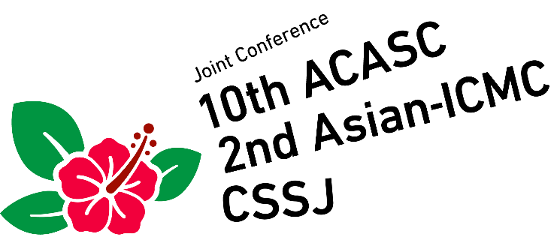

January 6-9, 2020, Okinawa, Japan

Application Form for Exhibition

Please fill up the Application Form and send it to Secretariat of the 10th ACASC/2nd Asian-ICMC/CSSJ joint conference by fax or e-mail:

Fax.: +81-3-3818-4573
e-mail: acasc-icmc-cssj@mlsrv.csj.or.jp

Number of booth ( ) booth
Price: 300,000 JPY/Booth (Tax included) Total amount: ( ) JPY
Payment by Bank transfer
Bank information:
Bank name: MIZUHO BANK, LTD.
Branch name: HONGO
Branch address: 3-34-3 Hongo, Bunkyo-ku, Tokyo 113-0033, Japan
Swift code: MHCBJPJT
Beneficiary’s Account No. 075-2873771
Beneficiary name: Cryogenics and Superconductivity Society of Japan
Purpose of the remittance: Exhibition booth

Note:
- Up to two registrants per booth can participate in the program (excluding banquets) without extra charge. The complimentary registrants can also apply for options (school, banquet and excursion) from the on-line registration site. However, if the registrant is going to submit a paper or if you would like to register a third participant or more, please make a registration as a regular attendee from the registration site.
- Your booth will be allocated and fixed after the confirmation of your bank transfer.

Exhibitor Information:
Affiliation:
Contact Person:
Name of Registrants:
(up to two)
Address:
Phone:
Fax:
E-mail:
Thank you very much for your cooperation.

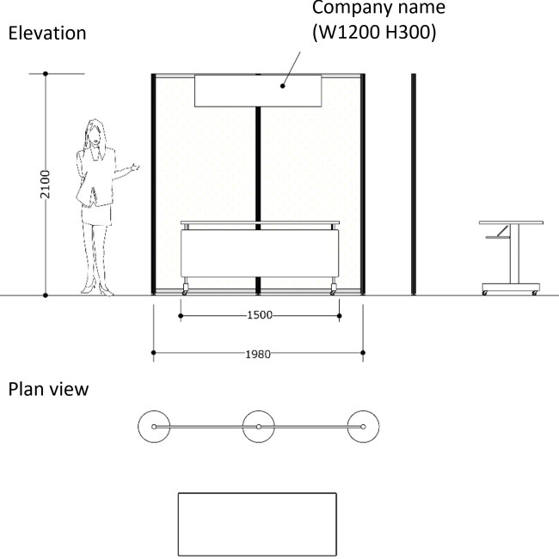

Schedule (tentative)
- For preparation: After 1 p.m., Jan. 6, 2019.
- The period of exhibitions: From Jan. 7 to noon Jan. 9, 2019.
- For carry out: After 1 p.m., Jan. 9, 2019.

